Lab Exercise 20
App Deployment Using ECS And ECR

Step 1: Create ECR Repository
· Go to AWS Console
· Search Elastic Container Registry (ECR)
· Click Create Repository
· Give name (example: my-web-app)
· Click Create

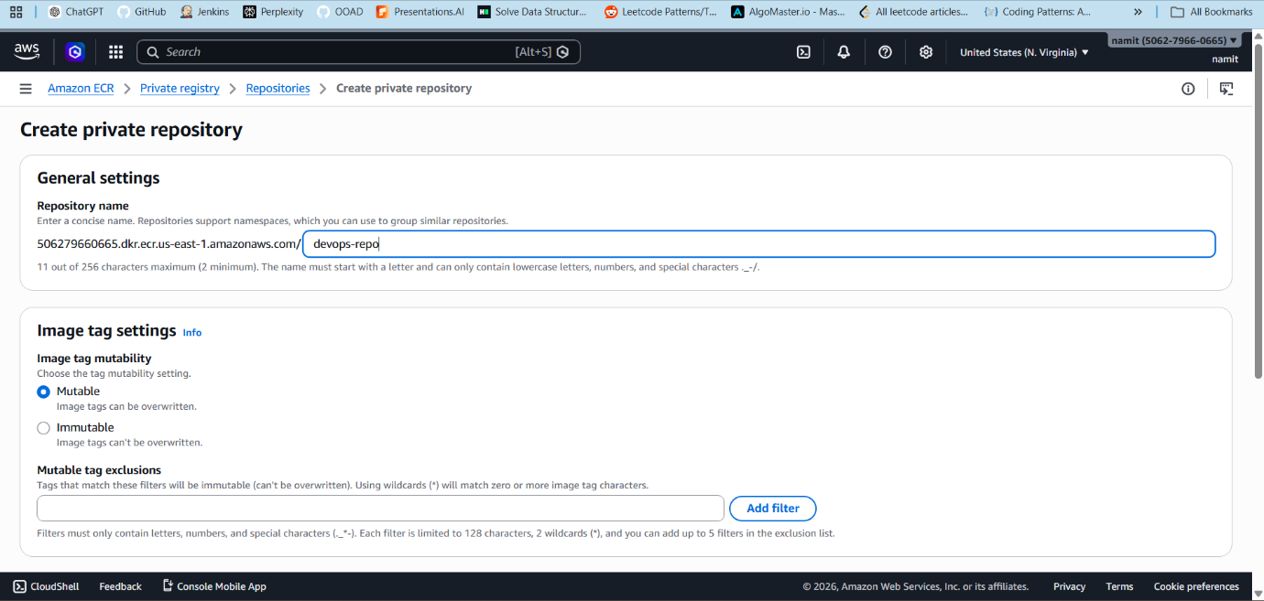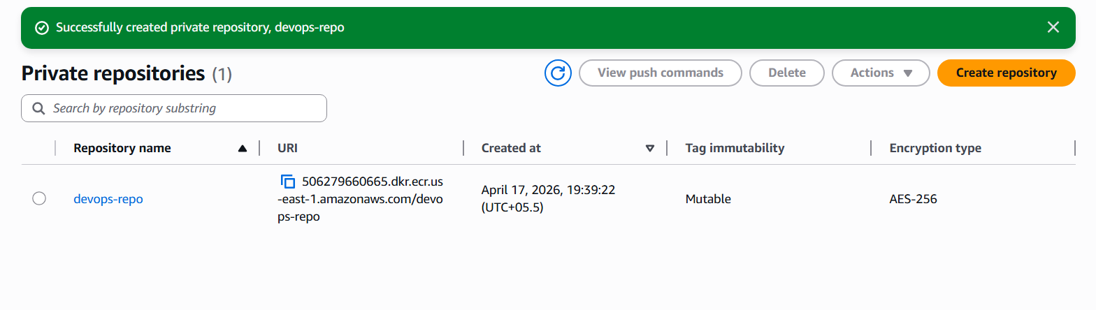

Step 2: Configure aws
Create access key
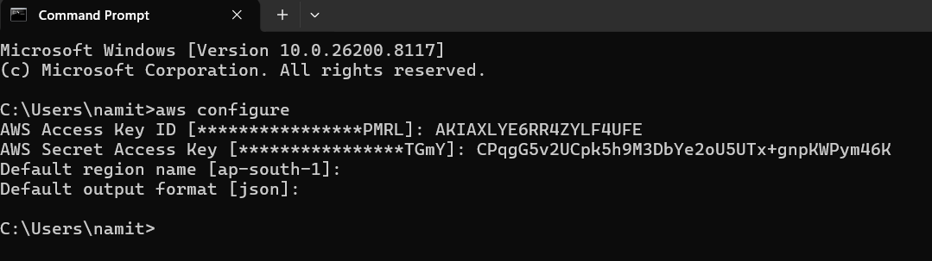

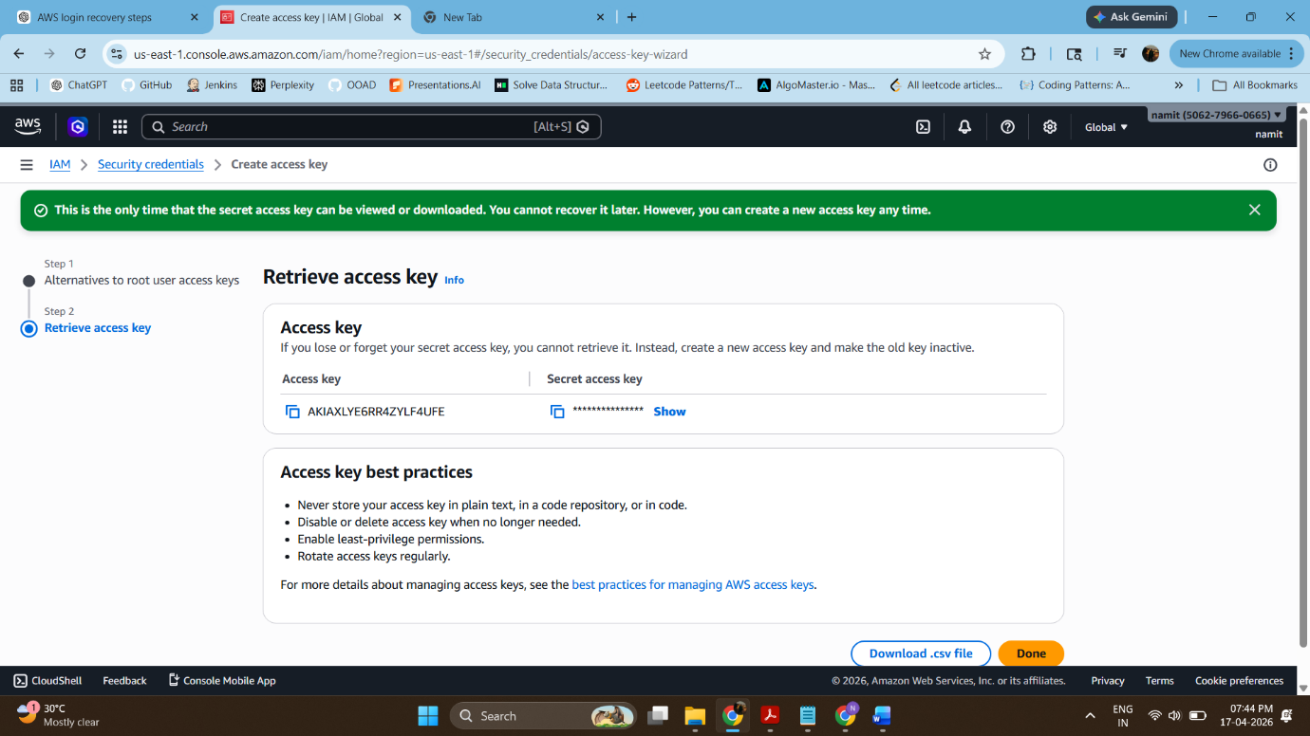

Step 3: Authenticate Docker to ECR

Step 4: Build Docker Image
Run this :
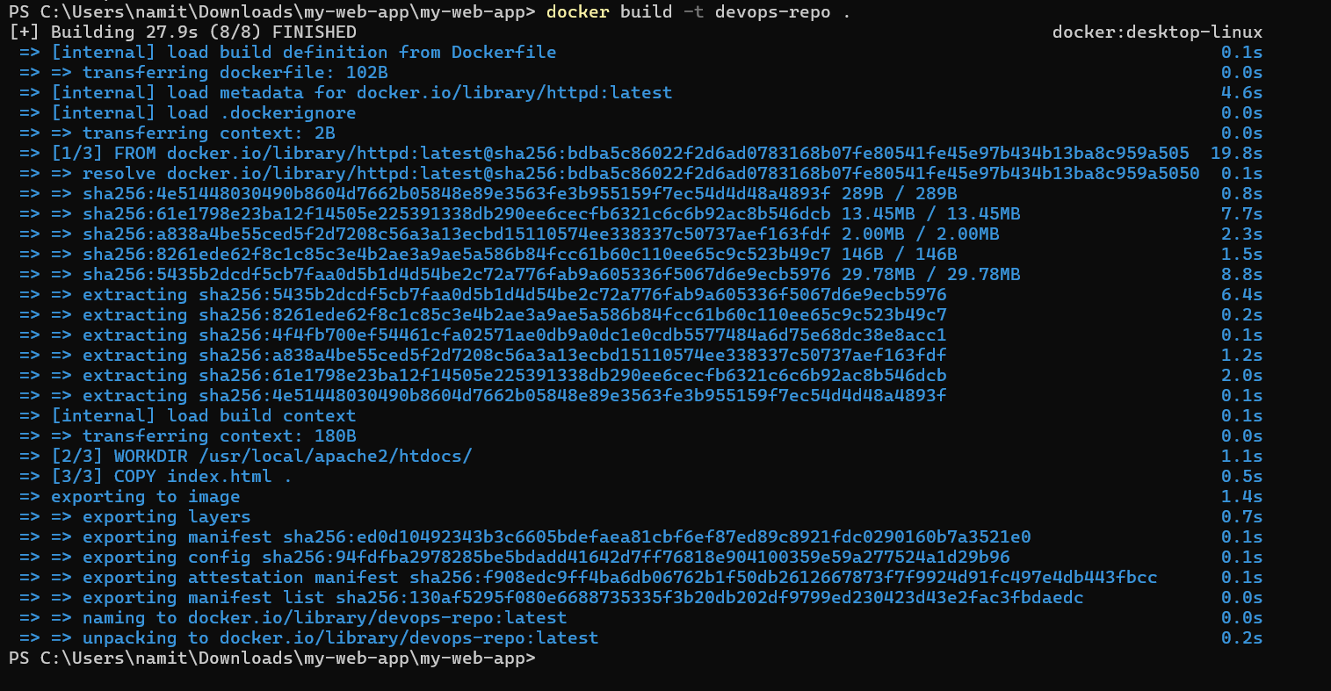

Step 5: Tag Docker Image

Step 6 : Push Docker Image
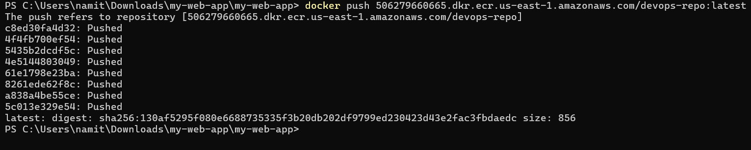

Step 7: Create Cluster
1. Go to ECS
2. Click Create Cluster
3. Select Fargate (Serverless)
4. Cluster Name: devops-cluster-new
5. Click Create

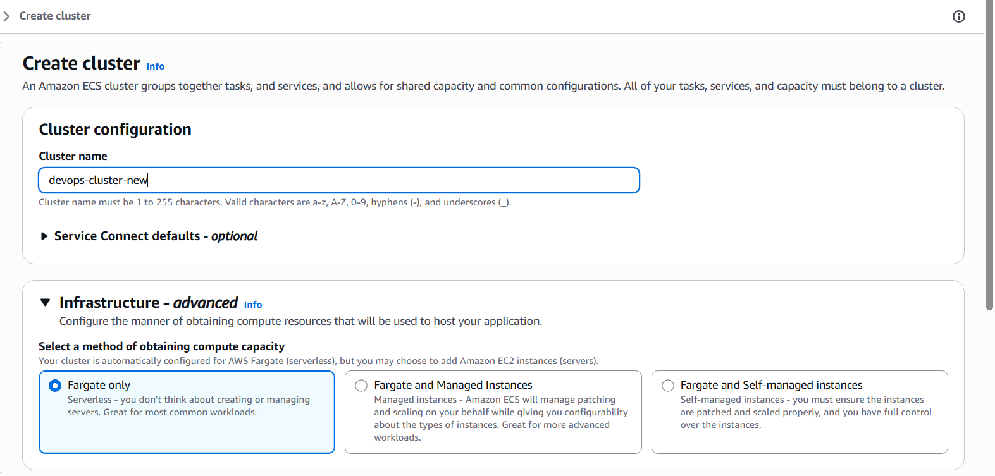
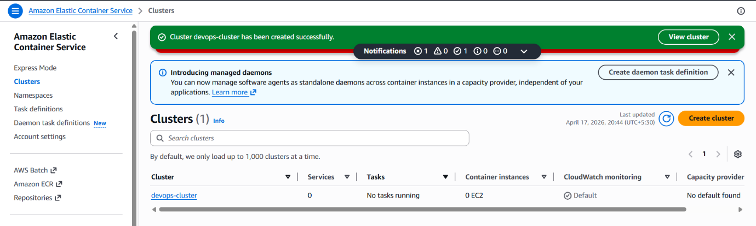

Step 8: Create Task Definition
1. Launch Type → Fargate
2. Container Image → Paste ECR URI

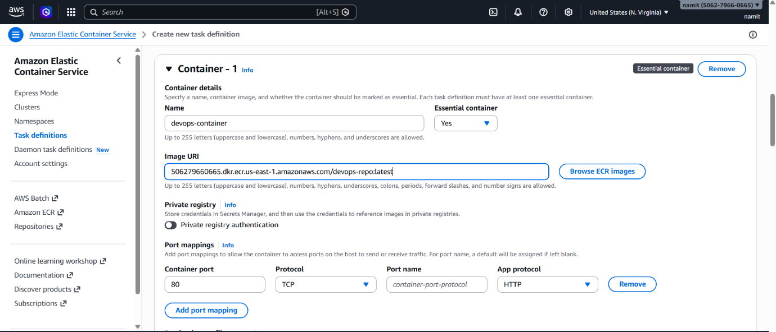

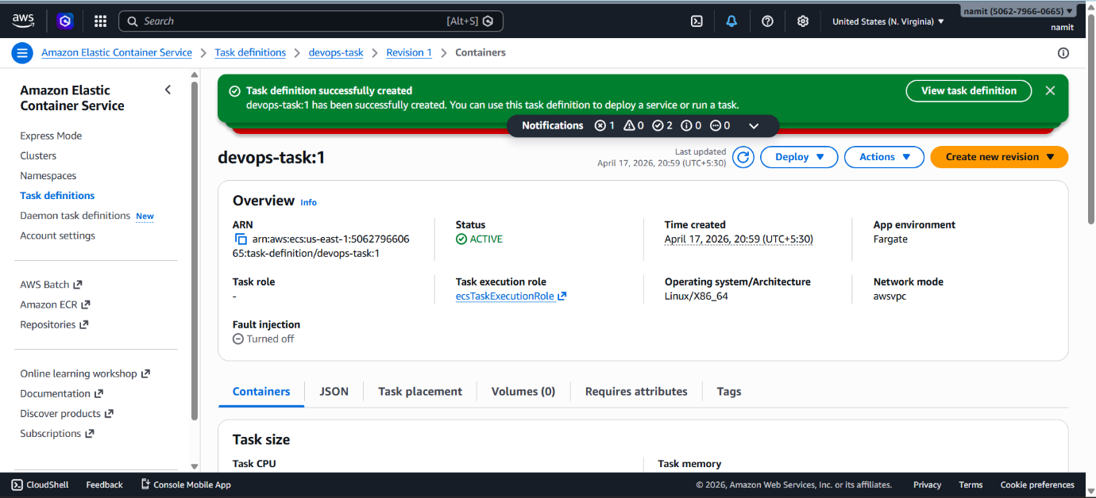

Step 9: Create Service
1. Go to Cluster
2. Click Create Service

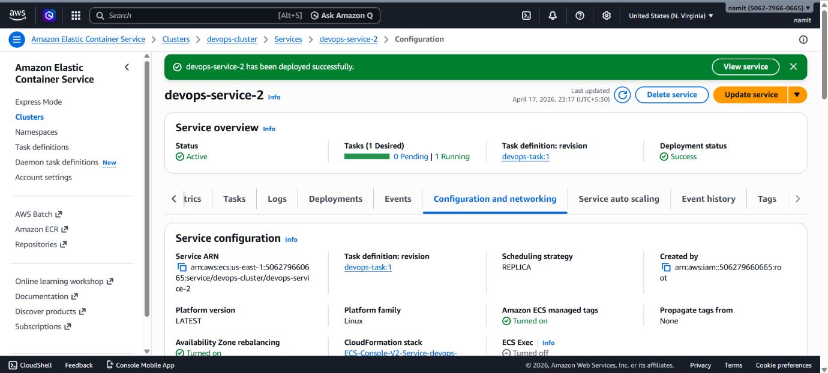

Step 10: Turn on all traffic in security broke

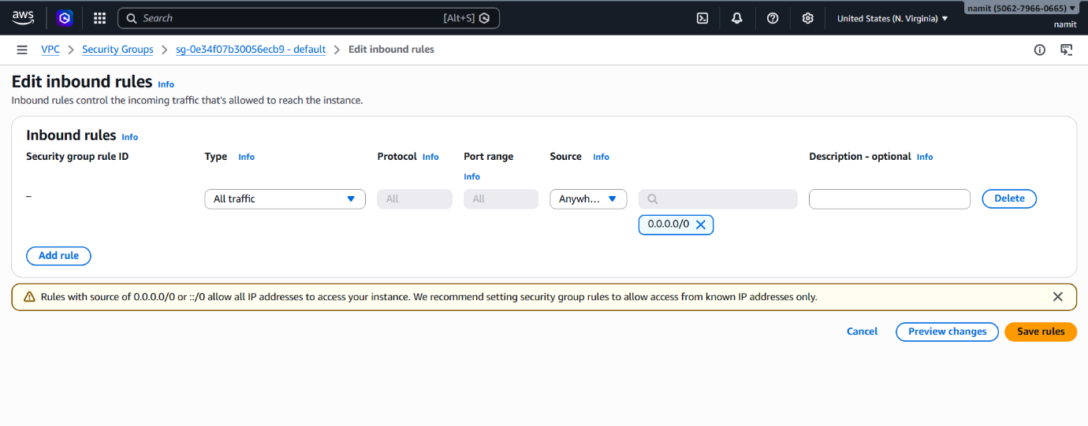

Step 11 : Verify Deployment
1. Go to Load Balancer
2. Copy DNS Name
3. Paste in Browser

http://35.172.201.211/

